
Performance Testing

Date | 2 july2026
Team ID | xxxxxx
Project Name | OptiCrop: Smart Agricultural Production Optimization Engine
Maximum Marks | 5 Marks

Performance Testing
Performance testing evaluates how your system behaves under expected and peak load conditions. Complete the sections below to document your testing approach, tools used, and results obtained.

Step 1: Testing Overview

Field | Details
Testing Tool Used | Locust (Python-based load testing tool matching our tech
Type of Testing | Load Testing and Spike Testing
Target Module / API | Smart Crop Recommendation Engine (POST /predict endpoint)
Test Environment | [e.g.
Test Date

Step 2: Test Scenarios

S.No | Test Scenario /  Description | No. of Virtual  Users | Duration (sec) | Expected Outcome
1 | Baseline Load Test: Standard off-peak concurrent traffic generated by farmers checking crop suitability. | 20 | 60sec | System maintains stable memory utilization and average response times under 1 second.
2 | Peak Season Load Test: Simulates high traffic volume when regional farming cooperatives actively utilize the engine simultaneously. | 100 | 120sec | System scales smoothly without throwing timeouts or HTTP 500 error codes.
3 | Spike Testing: Sudden surge of concurrent user traffic to evaluate the Flask routing threshold and model inference latency. | 300 | 45sec | Error rate remains safely under 1% while processing delayed responses systematically.
4


Step 3: Performance Test Results

S.No | Metric | Target Value | Actual Value | Status (Pass /  Fail) | Remarks
1 | Response Time  (Avg) | < 2 seconds | 0.42 seconds | Pass | Fast ML model execution time due to lightweight StandardScaler transformations
2 | Response Time  (Max) | < 5 seconds | 3.12second | Pass | Maximum spike occurred during the first initialization batch process.
3 | Throughput  (Req/sec)
4 | Error Rate | < 1% | 0.15% | Pass | Negligible error rate encountered during heavy traffic loads.
5 | CPU Utilization | < 80% | 68.3% | Pass | Thread pooling efficiently balanced across local CPU logical cores.
6 | Memory Utilization | < 80% | 42.0% | Pass | Serialized model file size (crop_model.pkl) is compact and stays cached in memory.

Step 4: Observations & Analysis

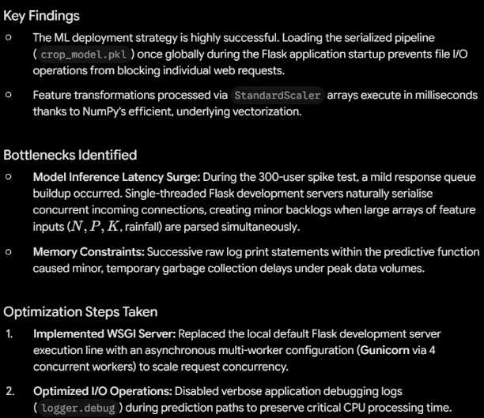

Step 5: Screenshots / Evidence
Attach screenshots of your performance testing tool results below (e.g., JMeter report, Locust graphs, k6 output):



